**MAHESH R**

[maheshsekaran724@gmail.com](mailto:maheshsekaran724@gmail.com)

 (+91) 70106 10585

Ts.no.9241, Dhandabanipuram 1st Street, Pudukkottai

 linkedin.com/in/mahesh-r10

 https://maheshr.netlify.app

 github.com/Mahesh20405

**SKILLS**

**Technical Skills**

• Programming Languages: Python, Java, JavaScript, RUST

• Tools & Frameworks: TensorFlow, MongoDB, Node.js, OpenWakeWord

• Machine Learning: U-Net for segmentation and classification, chatbot development

• Electrical Hardware Diagnosis

**EDUCATION**

**KONGUNADU COLLEGE OF ENGINEERING AND TECHNOLOGY**

***B.Tech:*** Artificial Intelligence and Data Science (2022-2026)

**CGPA:** 8.8, up to 5th semester, **GPA:** 8.87, up to 5th semester

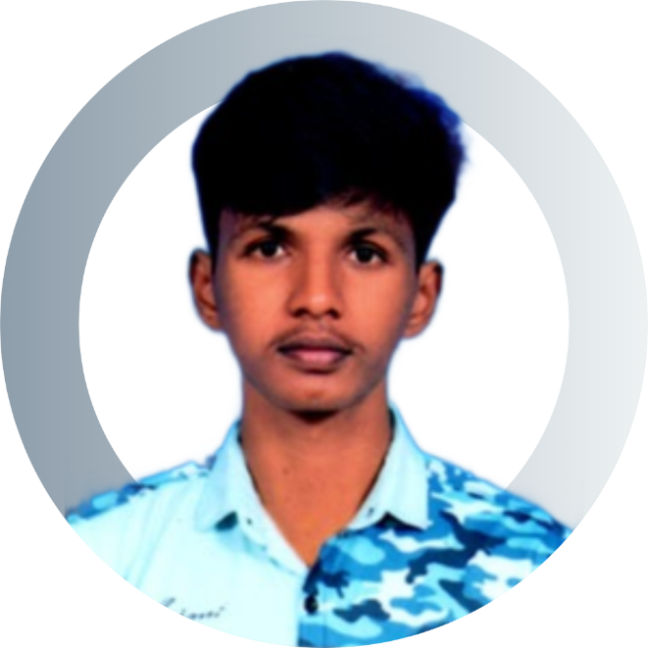

**EXPERIENCE**

**Internship**

**Frontend Web Development Intern**

VPRS Solutions, Pudukkottai

June 2024-July 2024

* Created and optimized minimalistic and performance focused frontend components.
* Collaborated with the design team to create responsive and user-friendly interfaces.
* Improved page loading speed and accessibility across multiple projects up to 22%.

**SUDHARSAN VIDHYA MANDIR MATRICULATION HIGHER SECONDARY SCHOOL**

* ***HSE:*** 2022-(88.33%)
* ***SSLC:*** 2020-(97.4%)

**CERTIFICATIONS**

* Tensorflow Professional Certificate (August 2024)
* Elements of AI (July 2024)

**LANGUAGES**

* English (C1)
* Tamil (C1)
* Japanese (A2)
* Hindi (B1)

**REFERENCES**

(Available upon request)

**PROJECTS**

**Pi Projector**

* An interactive and portable projector smart board with a custom OS using Raspberry Pi.
* It operates at just 20-25% of the cost of traditional smart board systems.

**Unified Chatbot “Athena”**

* Created a customizable chatbot with advanced integration and IoT compatibility.
* Focused dataset security.

**Steel Defect Detection**

* Applied machine learning models for defect detection in steel.
* It reduced the time for physical inspection of these defects by 37%.

**EXTRACURRICULAR ACTIVITIES**

**Lead, KNCET Skill Development Club**

KONGUNADU COLLEGE OF ENGINEERING AND TECHNOLOGY

* Managed club activities and coordinated with industry professionals to enhance technical knowledge.

**Boxing**

* Engaged in regular training.
* A strong commitment to physical fitness, competitive athletics, and academic pursuits.